Software Project Managing System

Aleksandrs Bistrovs 304542

Henrik Koster 305916

Kim Tranberg 172394

Laurentiu Mihai 304456

Astrid Hanghøj

Steffen Vissing Andersen

Software Engineering

First semester

7.10.2020

Table of content

Background description 1

Problem Statement 3

Definition of purpose 4

Delimitation 5

Methodology 6

Time schedule 7

Sources of Information 9

Appendices 10

Background description

Current demand for IT solutions is high and demand for IT solutions keeps increasing(Mordor Intelligence, 2020). Especially in the months following the current COVID-19 pandemic (Research Nester, 2020), where companies are forced to find new solutions that let their employees work from home (Felix Iblher, 2020).

Managing large IT projects is a very complex task while at the same time also very important and challenging. There are many reasons for this, such as technology required to meet a customer's demands can be very complex, time limited development and having to stay within budget.(F. John Reh, 2019)

Development of IT solutions is a very time consuming and expensive process, and can often become even more expensive than what was estimated before the start of a project. Things like not having a clear objective, requirements changing during the development process, lack of skills required to fulfill stated requirements by the customer and poorly managed time schedules. These reasons often lead to a finished solution that does not meet the requirements of the customer, which causes further development time and expenses (Michael Bloch, Sven Blumberg, Jürgen Laartz, 2012).

Updating customers on progress of their ordered projects is a very important aspect of customer satisfaction, keeping your customers satisfied is really important to all companies that sell products or services. Otherwise “Many times, however, consumers do not complain to the company, but instead take actions such as switching brands or engaging in negative word of mouth (WOM).” (Hawkins & Mothersbaugh, 2010, p. 636)

(Note that it was handed in as a previous group but was written by Kim Yung-un Supreme Leader)

Definition of purpose

The purpose of this project is to provide a company in question with an IT solution for their development projects, that helps the company in monitoring the progress and managing the work.

# Problem Statement

Managing large software projects is a very difficult activity to do, keeping an overview of all the tasks each requirement has, the progress, who is working on it and so on. It will quickly become unmanageable.

The following sub-questions are formulated to get a better understanding of the main problem:

1. How to efficiently manage software development projects?
2. What could be done to avoid a project falling behind schedule?
3. What kind of tools should be available to the user of the system?
4. In which way should customers be able to track progress of their projects?
5. What kind of information should be available to the customer?
6. Who is responsible for the cost, when the finished product does not meet the users requirements?

(Note that it was handed in as a previous group but was written by Kim Yung-un Supreme Leader)

Delimitation

Considering the time restrictions, the team will not be able to carry out the solution for large IT development projects.

The project is not going to include the consideration of the budget for such a system itself, as well as, a solution to the problem about the extra costs that could occur in case if the project does not meet the requirements.

Methodology

In the given project the development team will make use of the modified Waterfall approach. It consists of 5 stages, which follow strict, linear order, where each stage has to be fully completed before moving on to the next one (Winston Royce, 1970). In order for the Waterfall model to work, the requirements have to be well-defined, otherwise it is fairly easy to fail within this approach (Rumor, 2019). Since there is no possibility to navigate between the given stages, and fix the occurred problems on the way, the team has decided to use a modified version of the Waterfall method. It is being done in order to work around the previously mentioned issue by enabling the users of the model to go back and forth between the stages and fix the errors occurred during their work.

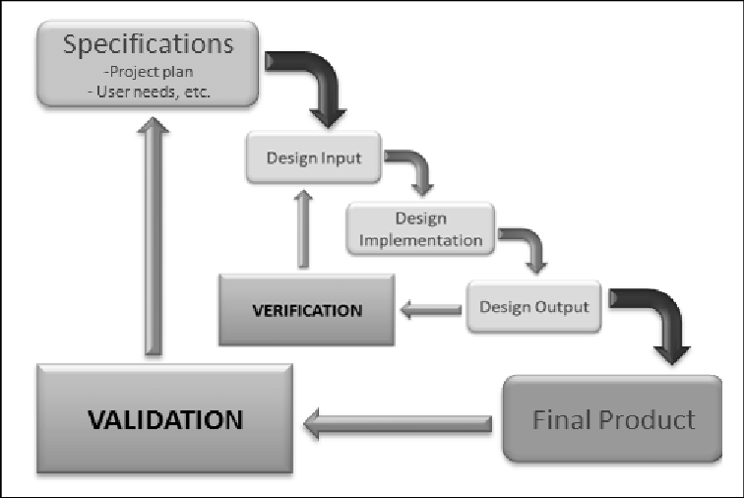

*Fig. 1. Waterfall method design process* (Koivukangas, 2015)

# 

# Time schedule

The expected workload is 27.5 hours per ECTS per student. And SEP1 is worth 5 ECTS so the total expected workload per student is 137.5 hours. The project spans 12 weeks so each member should spend 2.3 hours working on the project each workday of each week.

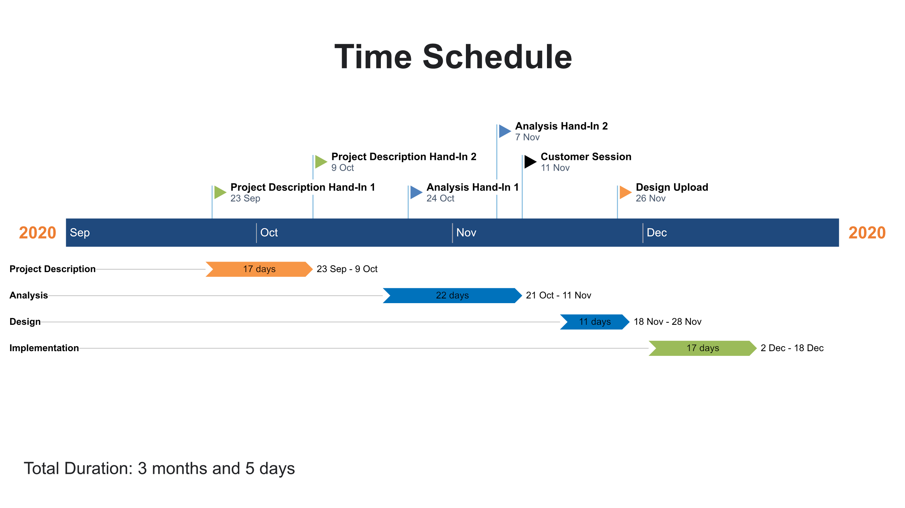

*Fig. 2. Gantt chart time schedule.*

Risk assessment

| Risk | Description | | Likelihood Scale: 1-5  (5 = high risk) | | Severity Scale: 1-5  (5 = high risk) | | Product of Likelihood and  Severity | | Risk Mitigation | | Responsible | |
| --- | --- | --- | --- | --- | --- | --- | --- | --- | --- | --- | --- | --- |
|
| Risk 1 | Lack of time before  hand-in/assignment | | 2 | | 3 | | 6 | | Assign internal deadlines for specific tasks,  more classwork. | | Everyone | |
|
| Risk 2 | Late hand-in/assignment | | 2 | | 3 | | 6 | | Assign internal deadlines for specific tasks. | | Everyone | |
|
| Risk 3 | Plagiarism | | 1 | | 5 | | 5 | | Reference all third party information/sources. | | Person who plagiarized work | |
|
| Risk 4 | Unequal workload | | 2 | | 3 | | 6 | | Divide tasks evenly between team members. | | Everyone | |
|
| Risk 5 | Crunch time | | 2 | | 3 | | 6 | | Complete most important tasks early on and  leave less significant work for the end. | | Everyone | |
|

# *Fig. 3. Risk assessment table.*

# 

# Sources of Information

Del I. Hawkins, David L. Mothersbaugh. 2010. Consumer Behavior: Building Marketing Strategy. 11th ed. New York: McGraw-Hill/Irwin

F. John Reh. 2019. *How to Successfully Manage Your First Project.* [online] Available at: <<https://www.thebalancecareers.com/how-to-successfully-manage-your-first-project-2276127>> [Accessed 8 Oktober 2020]

Felix Iblher, Andreas Oberlaender, Hendrik Willenbruch, Hugues Havrin. 2020. *It services: Who will win when demand bounces back*? [pdf] available at: <<https://www.oliverwyman.com/content/dam/oliver-wyman/v2/publications/2020/jun/IT_services_Who_Will_Win_When_Demand_Bounces_Back.pdf>> [accessed 8 Oktober 2020].

Michael Bloch, Sven Blumberg, and Jürgen Laartz. 2012. *Delivering large-scale IT projects on time, on budget, and on value.* (online) Available at: <<https://www.mckinsey.com/business-functions/mckinsey-digital/our-insights/delivering-large-scale-it-projects-on-time-on-budget-and-on-value#>> [Accessed 8 Oktober 2020]

Mordor Intelligence. 2020. *IT Services Market - Growth, Trends, and Forecast (2020 - 2025).* [online] Available at: <<https://www.mordorintelligence.com/industry-reports/it-services-market>> [Accessed 8 Oktober 2020]

Research Nester. 2020. *IT Managed Services Market: Global Demand Analysis & Opportunity Outlook 2023.* [online] Available at:

<<https://www.researchnester.com/reports/it-managed-services-market-global-demand-analysis-opportunity-outlook-2023/336>> [Accessed 8 Oktober 2020]

Royce, Winston. (1970). *Managing the Development of Large Software Systems*. [pdf] Available at: <<http://www-scf.usc.edu/~csci201/lectures/Lecture11/royce1970.pdf>> [Accessed 8 Oktober 2020]

Koivukangas Tapani. (2015). *Streamlining Medical Device Design Development Process from Research Laboratory to the Market.* [pdf] Available at: <<https://www.researchgate.net/publication/274570349_Streamlining_Medical_Device_Design_Development_Process_from_Research_Laboratory_to_the_Market>> [Accessed 17 November 2020]

# Appendices

Appendix 1. Group contract

**Group Contract**

***Group 4***

**Members:**

Aleksandrs Bistrovs **304542**

Henrik Koster **305916**

Kim Dahl Tranberg **172394**

Laurentiu Mihai **304456**

The following document has been developed and includes the code of conduct and cooperation between the team members of the group, where each member has to agree for the following terms and conditions as stated below:

**Participation**:

Strive for the best results, squeeze out maximum potential!

Invest the time, 2-3 hours each day - including the weekends.

Attend all the lectures, so everyone is on board.

Respect the team and their work, show interest for the project.

Try to divide the work equally.

**Communication**:

Talk about all the problems that arise during the project, try to find a solution between the members before calling in for help from the outside environment - supervisors.

Ask questions in case of doubt, make suggestions if there are any worthy ideas.

Give feedback to the team and be able to take constructive criticism from the peers.

**Meetings**:

Be serious and respectful towards the group members by showing up on the previously agreed meetings. Always come prepared and on time. In case of not being able to show up, always notify the team. Do not skip the meetings without a valid reason.

**Conflicts**:

When disagreements arise the team has agreed to solve them by a voting system. It means that the ideas which are backed up by the majority of the group are the ones which are taking place.

In case of any major conflicts or try to solve the problems by communicating within the group first. If that does not work - try to find a solution with the help of the supervisors.

**Deadlines**:

Respect the previously agreed time schedule and follow the deadlines. Try not to postpone the work until the last moment, thus making it sloppy and imprecise.

***Signatures: Date: 11.10.2020***